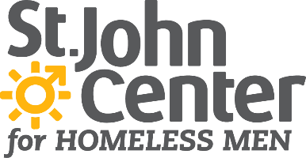 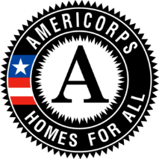

**Title:** **Housing Peer Support AmeriCorps Member**

**Reports to:** Supportive Housing Manager

**Type:** Full-time Year of Service (1700 Service Hours)

St. John Center helps homeless men address barriers to self-sufficiency and housing so that they may leave homelessness for good. By providing daytime shelter, social services, supportive housing, and serving as a hub with partner agencies, St. John Center is where homeless men **seek help, find hope, and move home.**

**Homelessness ends here.**

700 E. Muhammad Ali Blvd. Louisville, KY 40202 www.stjohncenter.org

**Description:**

The housing peer support AmeriCorps member provides support and mentoring for individuals in St. John Center’s Permanent Supportive Housing (PSH) Program. In tandem with other members of the PSH team, the peer support member assists housing clients in identifying needs and goals and providing supports and resources to help clients meet those goals. The housing peer support member uses lived experience in substance use, mental illness, and/or homelessness to provide a unique level of authenticity and understanding with clients and offers insights to the team regarding best practices. Harm reduction, housing first, trauma-informed and person-centered models are utilized by the PSH team.

**Responsibilities:**

The housing peer support AmeriCorps member provides positive support and builds self-sufficiency through such activities as:

* assisting clients in activities of daily living and orienting to a new apartment
* A person standing in front of a brick building

  Description automatically generatedguiding clients in locating and utilizing community resources and supports such as TARC, grocery shopping, food banks, employment, SNAP and social security benefits
* accompanying clients to medical and mental health appointments
* initiating and engaging in conversations around harm reduction and recovery
* accompanying clients seeking treatment or recovery support
* assisting clients in creating community connections
* Icon

  Description automatically generatedengaging in crisis intervention, supportive counseling, and life skills coaching
* facilitating harm reduction or peer support groups, as necessary

The housing peer support AmeriCorps member acts as a member of the PSH team and St. John Center staff team, and will utilize skills including:

* collaboration and working independently
* clear, timely communication
* understanding program objectives, goals, and philosophies
* abiding by HUD guidelines and policies
* documenting client interactions
* adhering to confidentiality guidelines and maintaining healthy professional boundaries
* using self-awareness to identify triggers and conflicts
* advocating for client and community needs
* participating in staff and team meetings
* cooperating with community partners and landlords
* representing clients and the agency appropriately in public
* embracing principles of harm reduction and recovery

**Physical Requirements:**

* Ability to travel throughout Metro Louisville to aid in apartment searches and perform home visits which may require ascending/descending full flight of steps, moving around in tight spaces, and other physical movement
* Standing or sitting for long periods of time, bending, light lifting, walking, climbing stairs

**Minimum Qualifications:**

* High School Education
* Basic computer literacy including word processing and Google suite
* Effective communication skills
* Must have personal automobile, valid driver’s license, liability insurance, and be willing to transport co-workers and/or clients

**Preferred Qualifications:**

* Completed the Kentucky State Peer Support Specialist Certification Training
* 2 years of experience in working with the homeless population
* ability and willingness to safely and effectively de-escalate situations, including conducting physical interventions when necessary to maintain safety as directed by agency

**Service Dates:** August 1, 2021-July 31, 2022 (with options for renewal)

**Compensation:**

* $33,000-$35,000 (mix of AmeriCorps living allowance and agency match funds)
* Health insurance provided through AmeriCorps
* Education award of $6,345 at completion of year of service
* Childcare assistance (if eligible)
* Ongoing training opportunities through AmeriCorps and St. John Center

**To apply:**  Send cover letter and resume to Sarah Buckler, Supportive Housing Manager, [sbuckler@stjohncenter.org](mailto:sbuckler@stjohncenter.org) by July 2, 2021.